The guide is designed to help users use the C++-based package that calculates Boltzmann entropy of numerical raster data.

Before installing gdal for Linux, please open the terminal and then run the following command one by one.

sudo add-apt-repository -y ppa:ubuntugis/ppa
sudo apt update
sudo apt upgrade

After that, you should input the command for Ubuntu 18.04 as follows:

sudo apt install gdal-bin python-gdal python3-gdal libgdal-dev

if your system is Ubuntu 20.04, the command should be:
[sudo apt-get install gdal-bin]

[Warming tips: you can run “sudo su” to change to the root. In this case, all gdal libraries will be automatically installed in the directory of “usr/local”, indicating that you do not need to set up the environmental variable.]

When the installation is completed, you can run “gdalinfo –-version” to check out the version of gdal installed in your system (see the following picture).
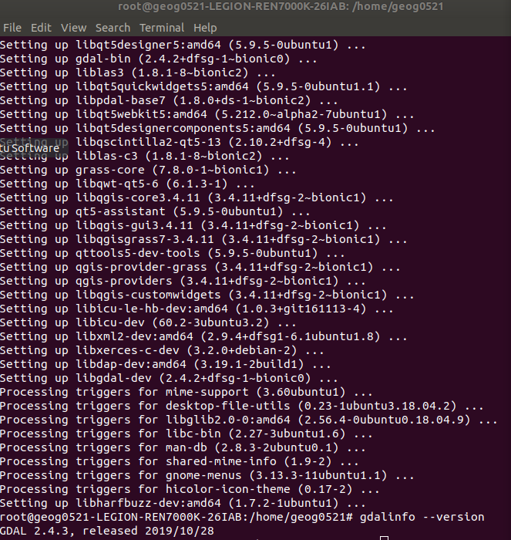

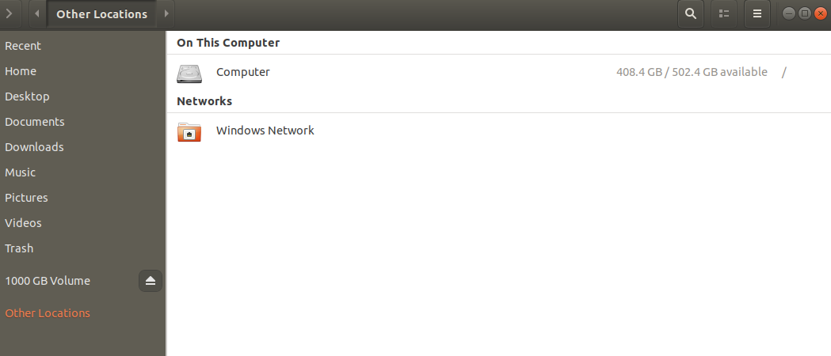
Click “other locations” and then click “Computer” on the right side to see the director of “usr”
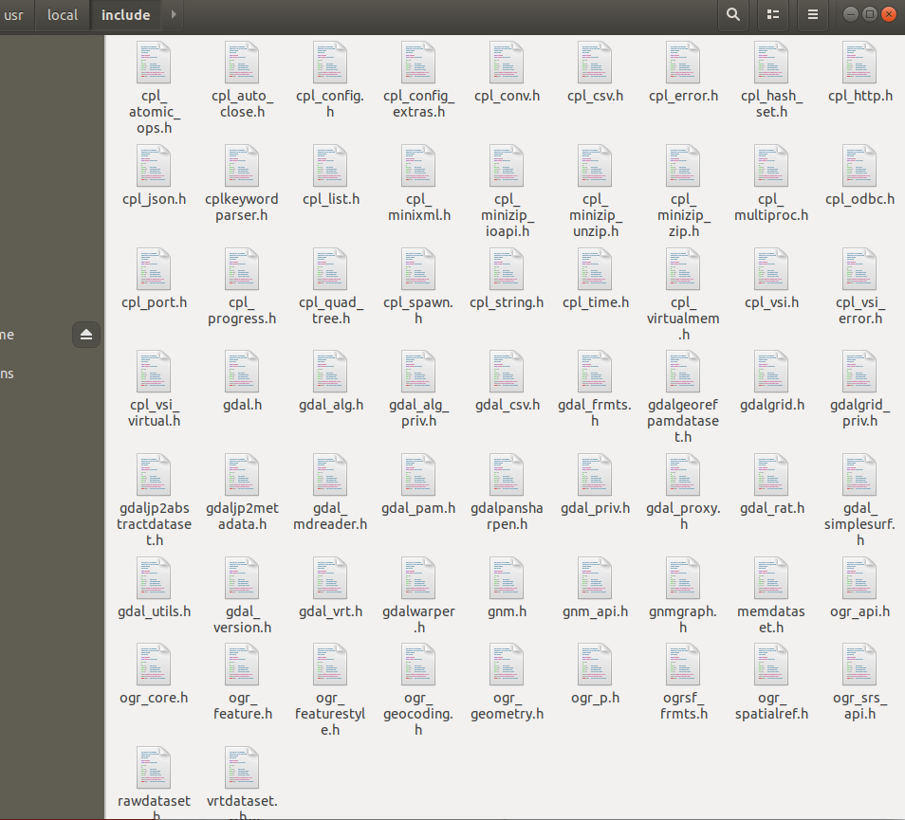

To test the GDAL, you should install G++ by the command of “sudo apt-get install g++”. Then, you can input the command of “g++ /home/geog0521/Desktop/testGDAL.cpp -lgdal -o hello” to get the compiled function called “hello”. Afterwards, you can input “./hello” to get the output-”hello world!”

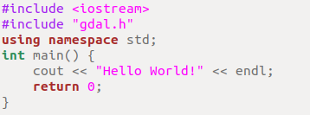

Fig 1. The codes in the “testGDAL.app”.
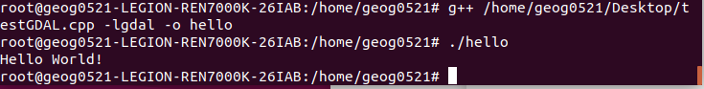
Fig 2. Results of running the compiled function of “hello”.

Next, you should compile the c++ file (i.e., cppBE_0414_test.cpp) of calculating Boltzmann entropy with the following command:

g++ /home/geog0521/Desktop/BECplusplus/cppBE_0414_test.cpp -lgdal -o /home/geog0521/Desktop/BECplusplus/BECplusplus_0414_test -lgomp

The compiled file is “BECplusplus_0414_test”.

Then, you can use to calculate the Boltzmann entropy of an image with the command as follows:

./BECplusplus_0414_test /home/geog0521/Desktop/BECplusplus/test_integer.tif 2 1 1

“2” represents the base for S = KlogW. The first “1” means normalization. The second “1” means that the output Boltzmann entropy value will be the sum of Boltzmann entropy of each band.

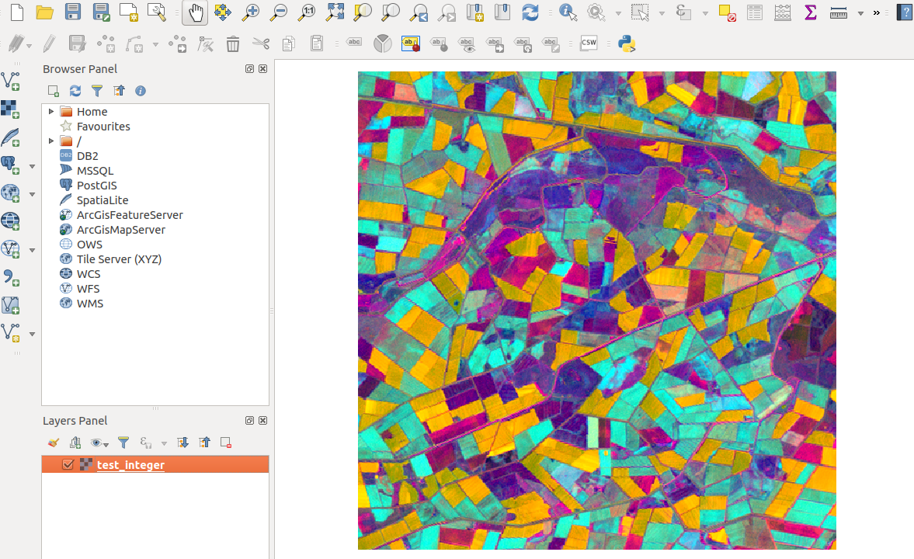
Fig 3. Test_integer.tif with three bands.

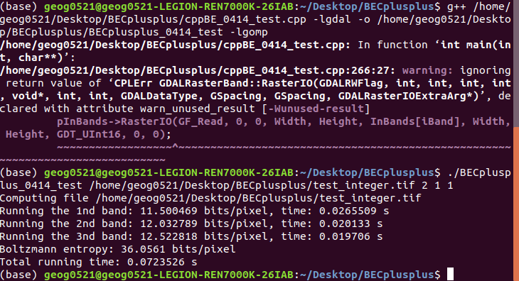
Fig 4. the computation results of Test_integer.tif.

In the python environment, you can use the following codes to calculate the relative Boltzmann entropy of Test_integer.tif

import subprocess

if __name__ == '__main__':
BEcomputa_results = subprocess.run(['/home/geog0521/Desktop/BECplusplus/BECplusplus_0414_test','/home/geog0521/Desktop/BECplusplus/test_integer.tif','2','1','1'],universal_newlines=True,stdout=subprocess.PIPE)
nmap_lines = BEcomputa_results.stdout.splitlines()
# print(nmap_lines)
BE_str = nmap_lines[len(nmap_lines)-2]
print(BE_str)
splited_str = BE_str.split(" ")
print(splited_str[len(splited_str)-2])

